# Chapter 1. Theory

## EMI in details

### EMC compliance

### EMI Definition

### EMI Classifications.

## EMI Filter Design

### Schematic Design

### Design Flow diagram

## RF Emissions Analysis

### Conducted Emissions

### Radiated Emissions

# Chapter 2. Filter mode

## Conducted Emission Analysis

### Common Mode Interference

### Differential Mode Interference

## Material Selection for Hardware Design

### Common mode Choke

### Lumped elements

### PCB design

## Noise Source Design

### Single tone signal

### Multi tone signal

# Chapter 3. Filter Behavior Prediction

## Linear Simulation

### S-parameter measurement

### Insertion loss measurement

## Non-Linear Simulation

### Voltage and current measurement

### Power measurement

### Stability measurent

### Attenuation measurement

# Chapter 4. Measurement and Comparison of Simulations

# Chapter 5. Result Estimation and Discussion

## Case Study 1: Filter for 230V and 50Hz source

## Case Study 2: Experimental Examples

### USB cables

### Ethernet cables

# CHAPTER 1. THEORY

## EMI details

### EMC compliance

In a designed system, electronic or electrical devices emit a large amount of electromagnetic interference known as radiated and conducted emissions and electromagnetic immunity known as conducted and radiated immunity. These emissions and immunity innate the entire performance of the system and may cause unwanted effects such as physical damage to the equipment. Electromagnetic compatibility (EMC) is the measurement ability of equipment in an electromagnetic environment without introducing intolerable electromagnetic disturbance to function satisfactorily. The main purpose of EMC is to limit the generation of unintentional signals and those signals propagation as well as reception of electromagnetic energy as output.

EMC pursues two main classes of issues. EMC may be defined by understanding and identifying any or all of these issues.

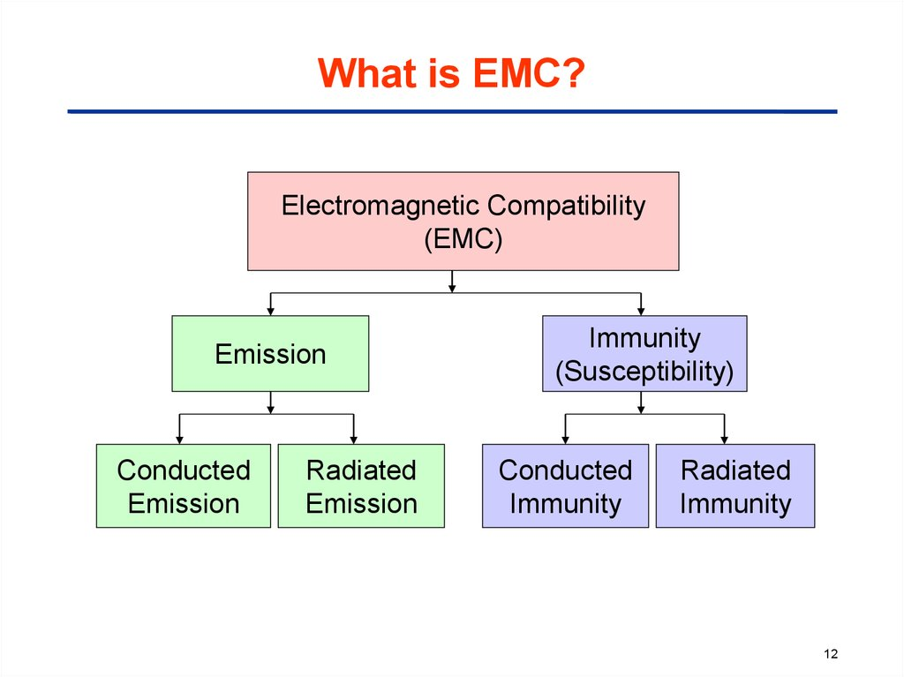

Figure 01: Classes and subclasses of Electromagnetic compatibility

https://en.ppt-online.org/152151

**Emission** is the production and discharging of electromagnetic energy by some source whether deliberate or accidental way, that release into the environment. EMC takes these unwanted emissions into consideration and countermeasures which mostly reduce unwanted emissions.

Electrical equipment that becomes malfunctioned or breaks down in the presence of unwanted emissions, isreferredas **Susceptibility** orRadio frequency interference (RFI). In case of **Immunity,** when a radio frequency is present in a system or equipment it functions correctly. Hardening equipment is also known as susceptibility or immunity.

A third issue which is a very common content of EMC is **coupling** by which emitted interference reaches the victim.

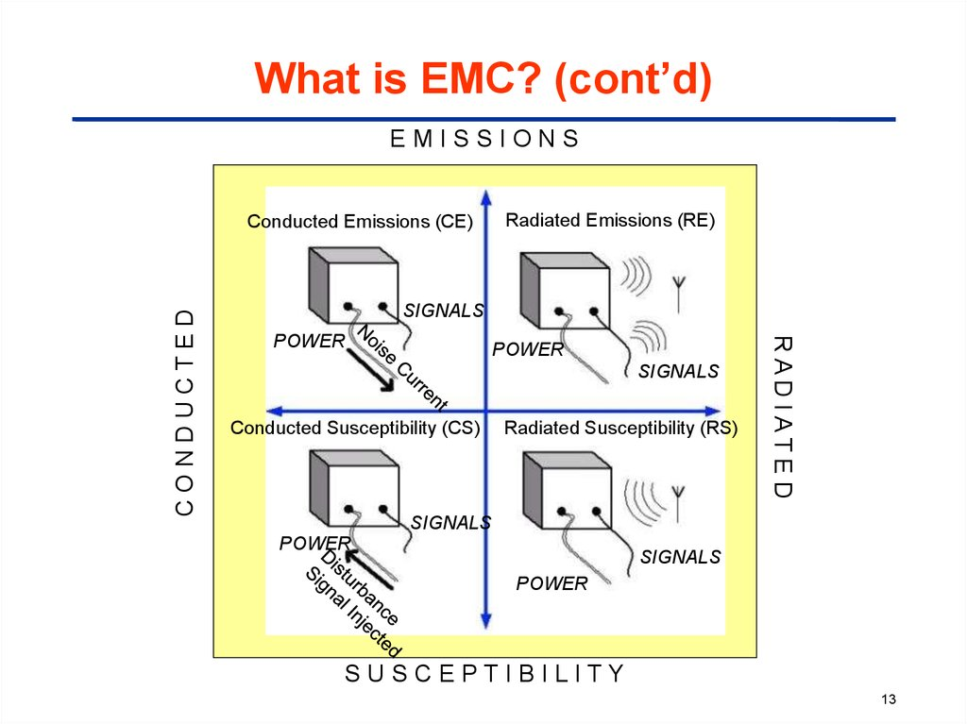

Figure 02: Measurement relationship between EMC classes

(https://en.wikipedia.org/wiki/Electromagnetic_compatibility)

### EMI Definition

Electromagnetic Interference is referred to as an electromagnetic disturbance that may degrade the performance of a device, equipment, system, or subsystem and create malfunction to the equipment generating electromagnetic induction or emitting electromagnetic radiation.

Generally, when an electric field comes in contact with a magnetic field, electromagnetic (EM) waves are generated. EM waves can travel at a very high speed like the speed of light in vacuum and can travel over anything whatever it is air or solid material or wave. It occurs when an electronic device is unshielded to an electromagnetic field and any device that has electronic circuitry and is connected with power supply, can be responsive to EMI.

EMI is the combination of two or more waves that can result in greater, lesser, or equal measured waves than the original one. Hence, the resulting wave may be potentially different from the original waves and may also be potentially unsuitable for its purpose.

### Electromagnetic Interference Classification

1. EMI can be generated from different sources. The way of classifying the EMI types is done by the way it was generated:

**Human-made EMI:** This type of EMI is generally generated from the electronic circuits or electrical devices. Examples as power lines, auto ignition, fluorescent lights, and so on.

**Naturally induced EMI:** This type of EMI can be generated from many sources like extraterrestrial sources including radiation from the sun and galactic sources including radio stars, galaxies, and other cosmic sources, atmospheric charge or discharge like lightning.

1. Second method of classifying the EMI types is by its duration:

**Continuous interference:** When a circuit is connected to a source and emits a continuous signal then this type of EMI generally arises from that source. However, background continuous noise may be created in a number of ways either it is human-made or naturally induced.

**Impulse interference:** Including lightning, ESD, and switching systems all those which contribute to impulse noise, is a form of EMI. This type of EMI may be generated by human-made or naturally.

1. EMI can also be classified according by their bandwidth.

**Narrowband:** This EMI is likely to be a single carrier source. The signal that is caused by intermodulation and other forms of distortion in a transmitter, also a form of narrowband EMI which may appear at different points in the spectrum. It may be responsible for inducing interference to another user.

**Broadband:** Broadband EMI can be generated from different sources. Man-made broadband interference can be generated from sources spark is continuously generated. Naturally occurring broadband noise can be generated from the Sun. Actually when the Sun appears behind the satellite and noise can mask the wanted satellite signal.

## EMI Filter Design

In this paper, EMI filter is designed considering the basic components a low pass (LC) filter basically need. Instead of parasitic inductor I have used a current compensate choke (coupled inductor) and parasitic capacitors.

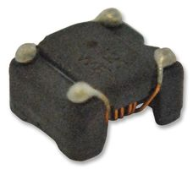 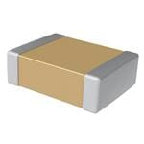

Figure 03: Passive components for building EMI filter

### Schematic Design

As there are two type of attenuation named common mode noise and differential mode noise that are generated in a circuit. In an EMI filter, different components are used among them the CX capacitors are used to attenuate differential mode noise. Generally, differential mode noise are created from line to neutral by rapid changes in current within the loop of the converter and also the generation due to the leakage inductance. Coupled inductor L is a common-mode or current compensated choke that is responsible for generating leakage inductance also. On the other hand, common mode noise is generated by rapid voltage change within the converter, and current flows from the line and neutral to ground. The choke has a high impedance and each CY capacitor is diverting noise current to the ground.

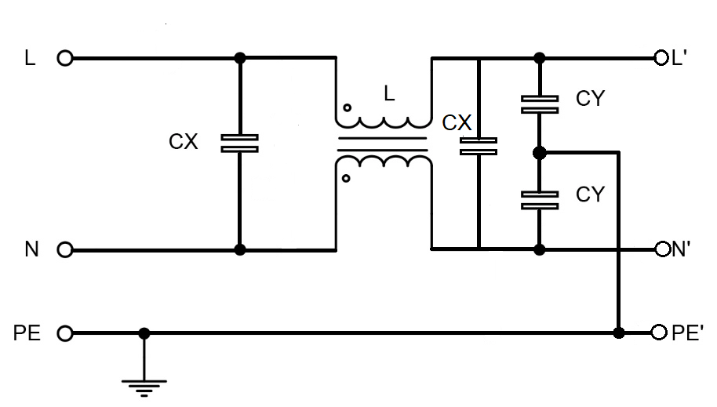

Figure 04: Standard schematic design of EMI filter

### Design Flow diagram

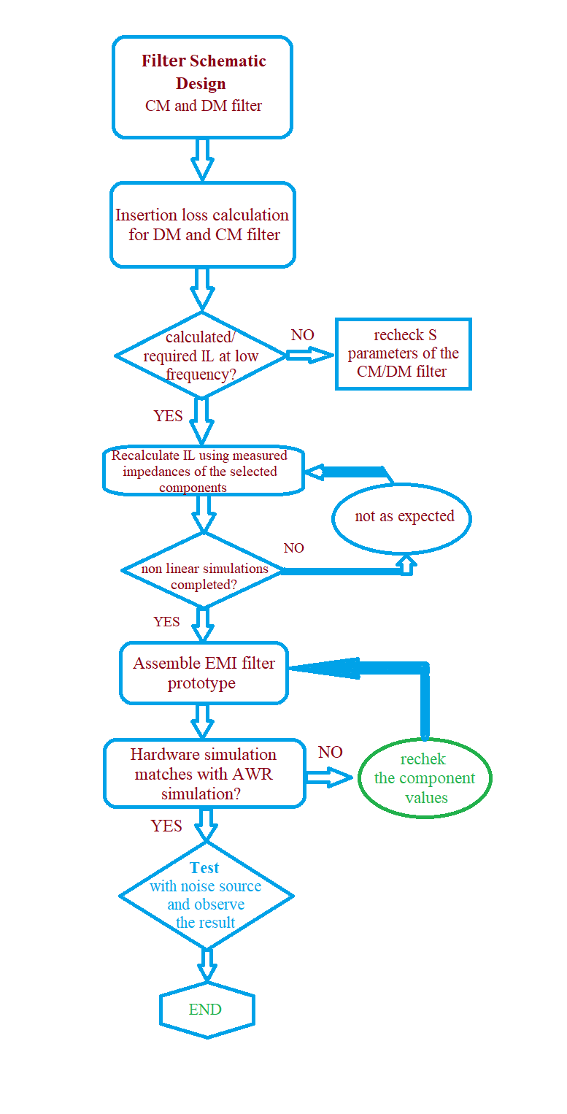

## EMI Emissions Analysis

When an electromagnetic energy is generated by any source whether accidentally or deliberately and is released into the environment then the existence of Emission is establish. EMC studies allows to identify these unwanted emissions and the countermeasures which may be taken in count to reduce this unwanted emissions.

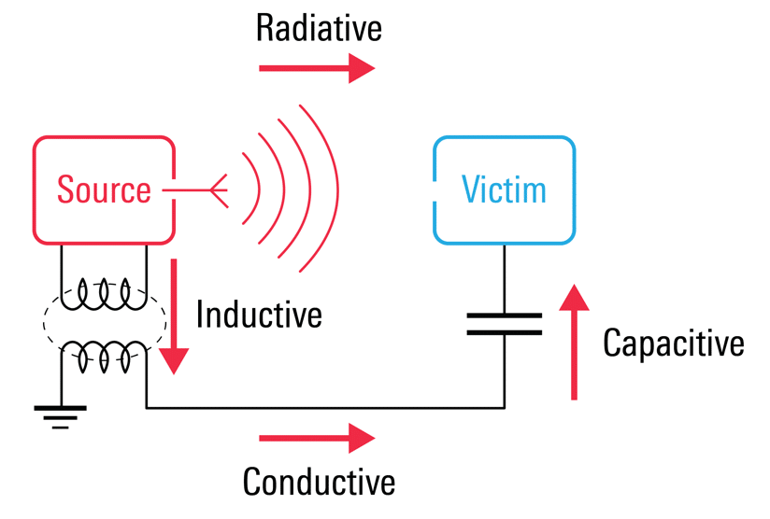

Figure 05: Induced emissions in an EMI filter

https://interferencetechnology.com/cost-effectively-ensure-electromagnetic-compatibility-in-the-age-of-iot/maxwellfig3/

### Conducted Emission

Conducted Emission refers to the mechanism where electromagnetic energy is created in an electronic device or sub-circuit and transferred to another device or sub-circuit via cabling, PCB traces, power or ground planes, or parasitic capacitance. This emission is capable to travels through a conductive path. This emission can be continuous or discontinuous. Continuous emissions are emitted at a given frequency but discontinuous emissions are non-constant and occur sporadically.

The frequency range for conducted emissions standards is 150 kHz to 30 MHz. But this range may go higher or lower for specific standards. There are some standards that uses different frequency ranges. Different value of impedances is also a concern for the manufacturers.

The three most common standards CISPR 11, CISPR 14–1, and CISPR 22 and corresponding EN standards specify measurement in this frequency range. CISPR 13 (for broadcast receivers) and CISPR 15 (for lighting equipment) also require a similar range. CISPR 15 calls for measurement from 9 kHz to 30 MHz. Conducted EMI at below 9 kHz frequencies is usually categorized as low frequency while that between 9 kHz to 30 MHz is categorized as high frequency.

### Radiated emissions

Electromagnetic energy that is generated from an electronic device intentionally or unintentionally is called radiated Emissions. Radiated emissions spread through the air from the device’s chassis. It can also radiate from interconnected cables. HDMI ports are a good example that radiate emissions. Typical magnetic field loop antennas such as the Van Veen Loop antenna measures the magnetic field emissions of a product in three-axis.

Circuits are filled with time-varying signals that propagate electromagnetic radiation into space. In that sense, every conductor that carries electrical currents behaves like an antenna that source energy into the surrounding and simultaneously transmits and receives radiated EMI.

The standard frequency range given by CISPR22 and EN55022 standards was 30 MHz–1 GHz intended for computers and communications-related equipment. The emission levels for Class B components are 30 dBμV/m in the frequency range 30–200 MHz but emission levels increase up to 37 dBμV/m as the frequency increases 1 GHz from 200 MHz.

# Chapter 2. Filter mode

## Conducted Emission Analysis

Conducted emissions are electromagnetic interference (EMI) or noise that originates from an electronic or electrical device frequencies. These interference are then spread out along with interconnected cables. Cables may be signal ports, wired ports such as telecommunication ports or power conductors.

Conducted emissions are typically divided into two types: Common mode and Differential mode.

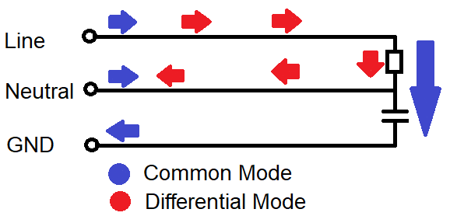

Figure: Conducted Emissions path in a designed device.

### Common Mode Interference

Common mode noise is referred as the line to ground noise that is generated both sides of the ac input and in phase with its ground. It is an asymmetric noise. The common mode noise current flows in the same direction on both power conductor line and neutral and returns via the ground conductor. Common mode noise can be suppressed by the common mode choke and the Y capacitors used in the EMI filter.

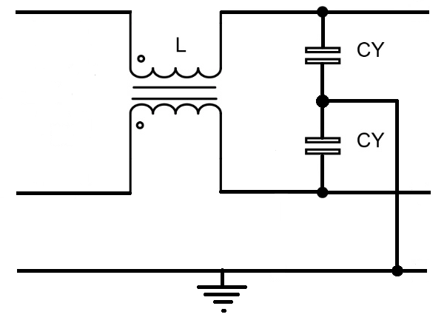

Figure: Common mode part in an EMI filter

#### Common mode voltage

Common mode voltage is asymmetrical and unbalanced voltage. It is defined as the voltage between conductor line and ground, or as the mean of the phasor voltages appearing between each conductor and a specified reference, usually earth or frame. If V1 and V2 are voltages on phase and neutral respectively, then the following expression gives the common mode voltage. The voltages induced by external electric fields are generally common mode voltage ‘VCM’ given by:

VCM = (V1+V2) / 2

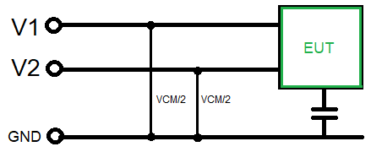

Figure: Voltage measurement of a Common mode filter

#### Common mode current

Common mode currents are those currents that flow in the same direction on line and neutral and return via ground. If I1 and I2 are currents on line and neutral, then the common mode current ICM is given by the vector sum of those two currents.

ICM = I1 + I2

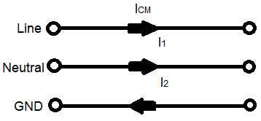

**Figure: Current flow in a Common mode filter**

#### Radiation due to Common mode noise

When in a system the electric field intensity radiates due to the common mode noise and current flow from transmitter to receiver having a specific distance then that field can be expressed by the equation bellow. Cable length L is an important factor to solve the equation. The distance from the observation point to the channel is denoted by r. So it is seen that the electric field id depended on the cable length proportionally.

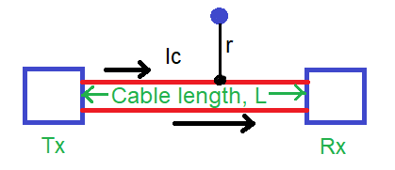

|  |
| --- |
| ECM ∝ |

https://techweb.rohm.com/knowledge/emc/s-emc/01-s-emc/6899

### Differential Mode Interference

Differential mode interference is referred as the signal that is generated in between line and neutral and because of the leakage inductance of the common mode choke which is generated due to short of two port of the choke.

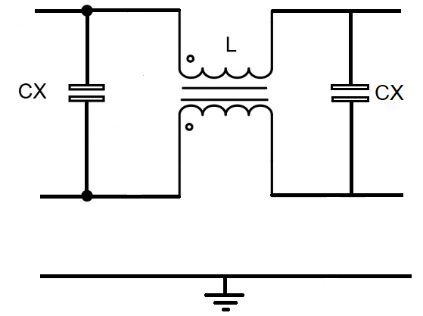

#### Differential mode voltage

Differential mode is said to be normal mode or symmetrical mode and it has balanced voltage. It is defined as the voltage between two wires of a two conductor line. Voltage VDM is the differential mode voltage and is the vector difference of the voltages on phase and neutral is given by:

VDM = V1 – V2

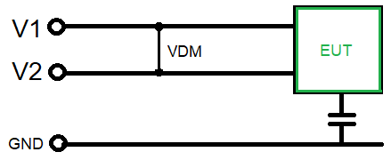

#### Differential mode current

Differential mode currents are defined as half the vector sum of currents flowing in any two of a specified set of active conductors at a specified cross section area. In simpler terms differential mode currents are those currents which flow in opposite directions on phase and neutral. The differential mode current is given by:

IDM = (I1 – I2) / 2

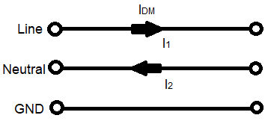

#### Radiation due to differential mode noise

The electric field intensity of differential mode noise can be presented using the following equation where the noise current flowing in differential mode is Id, distance to the observation point and the noise frequency are ‘r’ and ‘f’. Differential mode noise creates a current loop which is generally the noise current. We have considered that loop area S. From the following equation it can be estimated that if the loop area becomes larger the electric field intensity gets higher and vice versa. From the following equation it can be estimated that if the loop area becomes larger the electric field intensity gets higher and vice versa while keeping the rest of the elements constant.

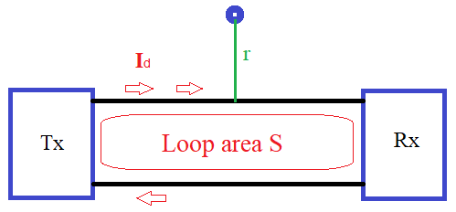

|  |
| --- |
| EDM ∝ |

<https://www.pearl-hifi.com/06_Lit_Archive/02_PEARL_Arch/Vol_16/Sec_51/4530_Electromagnetic_Compatibility_Engineering.pdf>

## Material Selection for Hardware Design

### Common mode Choke

In electronic circuitry a common mode choke is use to suppress the common mode noise and recognized as an electrical filter. It blocks the high frequency noise and let the low frequency signal to pass. Common mode (CM) noise current radiates from sources and this noise arise interference problems in electronics circuits.

Chokes are basically two types. Single choke is used for differential mode suppression, and a common mode choke (current compensated) is used for common mode suppression. In our thesis, we have used a common mode choke. In the common mode choke, there are two windings or multiple windings, which means three line winding, or more can be possible. Here, we used two identical winding or coils around a common core in different direction. The basic property is that whatever the number of winding is made, all are on a common core.

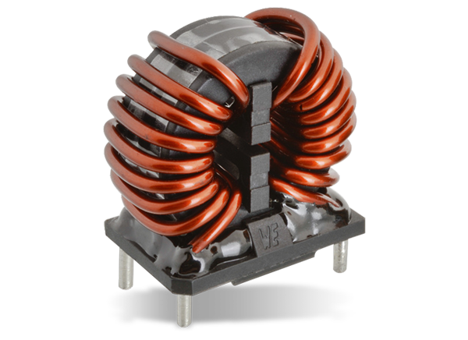 https://www.mouser.de/new/wurth-elektronik/wurth-we-cmbnc-power-chokes/

Windings are coupled together around this common core. Common mode choke has common mode impedances that suppress unwanted common mode noise. Common mode choke also has some differential mode impedance as well which is known as leakage inductance. Most importantly the overall distortion of the overall signal due to this leakage inductance is very low as the suppression does not occur at the transmitted signal frequency.

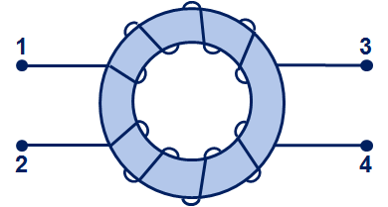 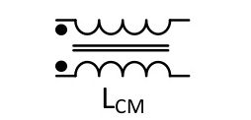

When a current enters in the CMC in the same direction, the two magnetic fields originated due to these directional coils are added together to provide a large inductance or impedance, which plays an important role in suppressing common mode noise.

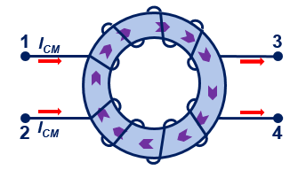

When the currents enter in the opposite direction of the CMC, they produce two magnetic fields in opposite direction of the windings and cancel each other. Then into the choke, a very little inductance or impedance generates which is called leakage inductance but the core does not saturate even with large input currents.

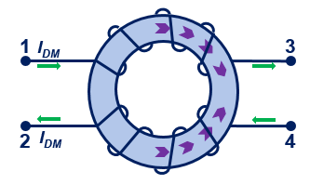

<https://electronics360.globalspec.com/article/11877/electrical-noise-suppression-and-common-mode-choke>

When a CMC is designed for the filter purpose in the circuit, it attenuates the energy down to a given frequency, which reduces the unwanted noise going to the load. On that time choke produce a large inductance and common mode noise are filtered out only. But the differential mode signal induced from the choke leakage inductance also pass through the filter.

Impedance

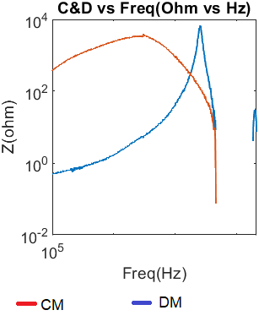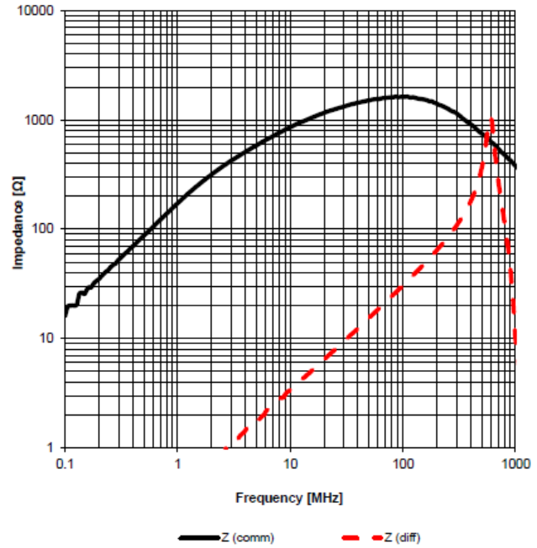

Figure: Impedance of Common Mode Choke 1. Measured 2. Theory.

### Lumped elements

EMI filter is designed of two capacitors connecting between the line and neutral wires (called X capacitor), two capacitors connecting between line to ground and neutral to ground wires (called Y capacitor), and a common mode choke. Due to the CM and DM noise current directions, the CM choke and the Y-caps (CY1 and CY2) affect both CM and DM emissions while the X-caps (CX1 and CX2) affect the DM noise. When the CM noise propagates through the EMI filter, the CM noise is suppressed by the equivalent CM filter. Since CY is placed by facing the noise source, the equivalent CM filter is a CL-configuration filter. At the same time, the DM noise is eliminated by the equivalent DM filter, which is a π-configuration filter. The equivalent CM filter comprises the CM inductance (LCM) of the CM choke at the load side and the parallel of CY1 and CY2 at the power supply side. The equivalent DM filter resulted from the total leakage inductance of two windings of the CM choke (LDM), the CX2 at the load and the CX1 at the supply side.

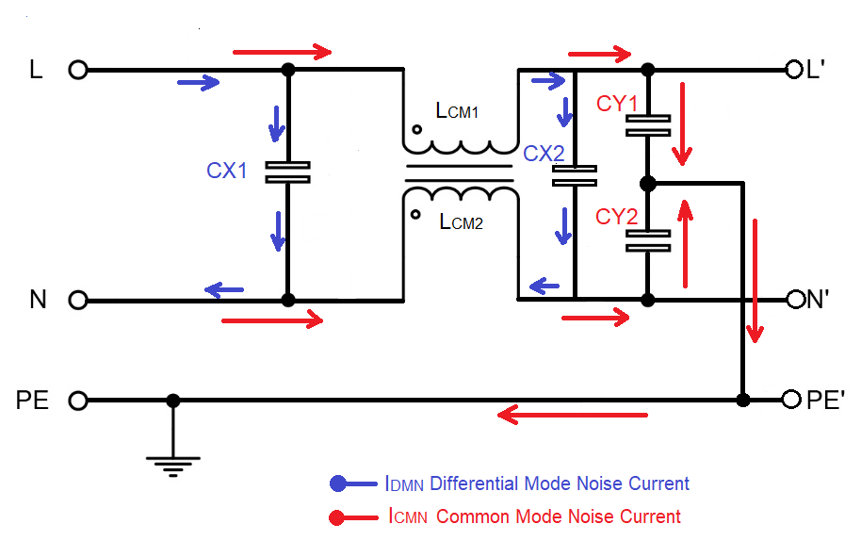

## Noise Source Design

In an electrical system noise is an unwanted signal that may generate during signal transmission, processing, receiving, storage or conversion. In an electromagnetic system noise generates harmonies that distort the main signal to pass.

In our thesis work we have considered a loss pass signal generator which is called Comb Generator. A comb is a signal generator that produces multiple harmonics having similar amplitudes in the input side. But as in the output the spectrum analyzer displays the signal like comb that is why it is named Comb Generator. Here we have used a comb generator which can generate signal up to 1 GHz at frequency interval of 12MHz. That means from 12MHz we will get signal response at 12 MHz and similarly at 36 MHz, 60 MHz, 84 MHz, 108 MHz, 132 MHz, 156 MHz, 180 MHz, 204 MHz and so on. As we are getting signal response, we will get harmonics at exactly 24 MHz, 48 MHz and so on.

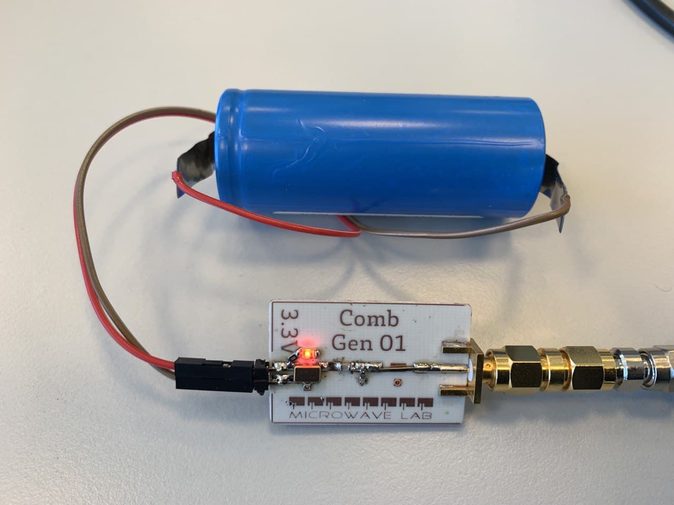



Figure: Hardware design of a Comb generator and the input power with frequency

## Line Impedance Stabilization Network (LISN)

LISN is actually used to measure how strong radio transmitter is when the RF emissions enter via the power supply wires. LISN lets the equipment under test to get its power supply uninterrupted and directs all emissions to the resistive load. Spectrum analyzer takes the measurement that load gets.

LISN is designed to provide a constant line impedance of over a frequency range required. Moreover, it minimizes the measured noise that is generated by EUT.

If we want to measure LISN performance, it is important to know how much external RF emissions are attenuated by the LISN from the power supply. As well as how much the RF emission is attenuated from EUT to the measuring equipment.

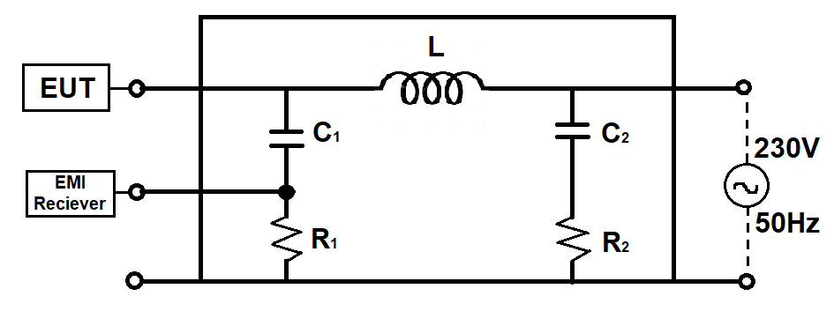

# Chapter 3. Filter Behavior Prediction

## Linear Simulation

### S-parameter measurement

S-parameters consists of two fundamental topics:

* Two-port networks,
* Reflections on transmission lines.

#### Two-port network

It is the most commonly used circuit analysis technique that obtains an equivalent circuit model with respect to the specified terminal pairs of the network. The fundamental principle of two-port network analysis is to calculate only the terminal variables (input voltage, input current, and output voltage, output current) instead of calculating voltages and currents of all points inside the circuit. In EMC the two-port network analysis calculate the voltages and currents in sinusoids at each frequency, described by their amplitudes and phases.

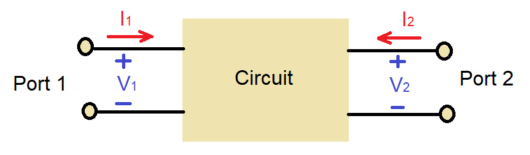

In a two-port S-parameters we can get four individual parameters which are:

S11 is the input voltage reflection coefficient

S12 is the reverse voltage gain

S21 is the forward voltage gain

S22 is the output voltage reflection coefficient.

To design an EMI filter and simulate this filter attaching with a noise generator we did some linear simulation to test the ultimate result. This linear simulation includes identifying S parameters of the Common mode choke, parasitic capacitors. We had to measure the S parameter of the common mode filter and Differential mode filter also. We have used Vector network analyzer to measure all these parameters.

The measured S parameters are defined as follow in the RF sub circuit we have implemented.

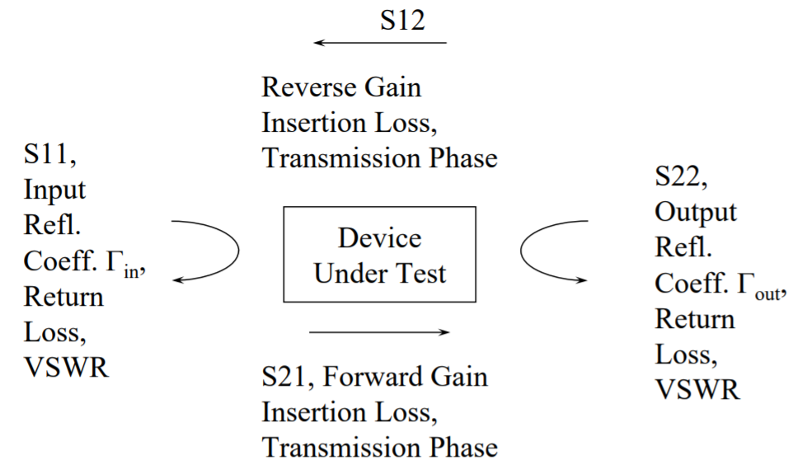







Figure: Hardware Measurement of S parameter of a) Common mode filter with no capacitor; b) Common mode filter with CY1=CY2=100pF; c) Differential mode filter with no capacitor; d) Differential mode filter with CX1=840pF, CX2=470pF; d) 2 Transformer.

Common Mode Filter and differential mode filter in software simulation

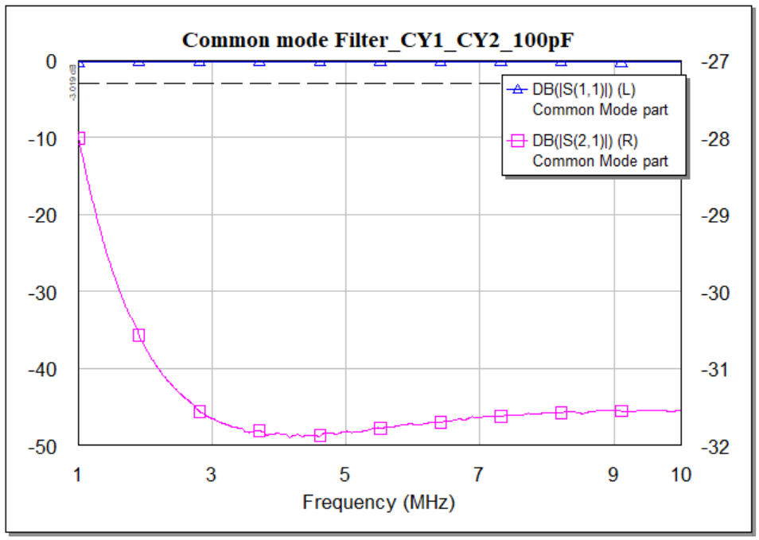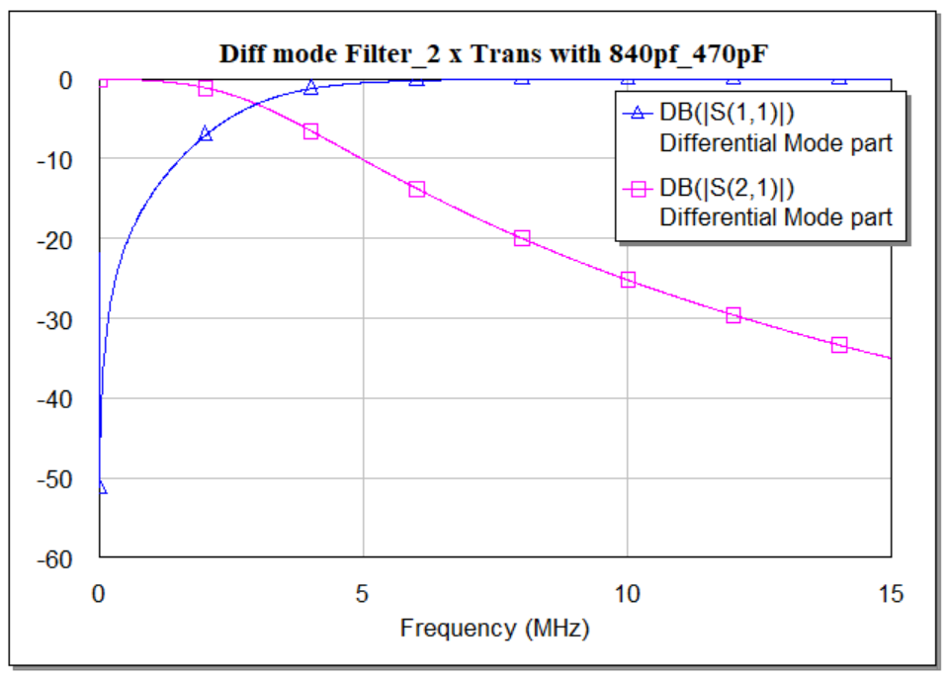

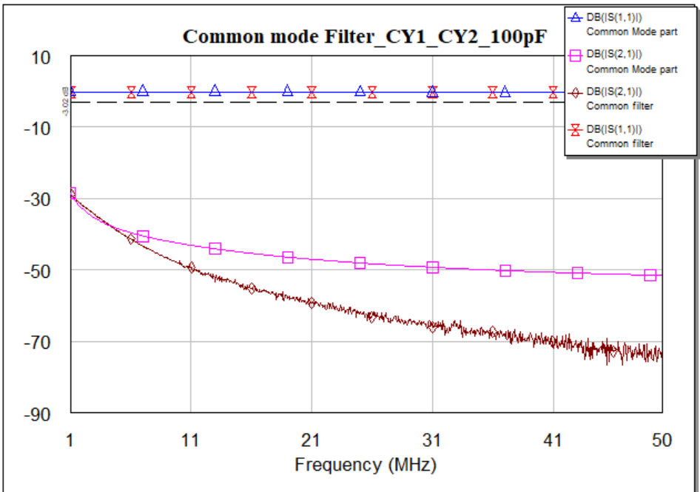

The input voltage and current can be measured using the S parameters. But for doing this another parameter analysis is used and this parameter analysis is called ABCD parameter matrix. During transmission of a signal, many losses can be occur in the transmission line which decreases the efficiency of the line. All of these parameters are used to minimize the losses. The conversion from S parameters to ABCD parameters can be followed by the following equations:

A = $\frac{\left(1+S_{11}\right)\left(1-S_{22}\right)+S_{12}S_{21}}{2S_{21}}$

B = $Z_{0}\frac{\left(1+S_{11}\right)\left(1+S_{22}\right)-S_{12}S_{21}}{2S_{21}}$

C = $\frac{1}{Z_{0}}\frac{\left(1-S_{11}\right)\left(1-S_{22}\right)-S_{12}S_{21}}{2S_{21}}$

D = $\frac{\left(1-S_{11}\right)\left(1+S_{22}\right)+S_{12}S_{21}}{2S_{21}}$

As all the S parameters are set of data in phasor form so ultimately we will obtain ABCD matrix in phasor form also. Here Z0 is called the line impedance which is considered as 50Ω. The voltage and current can be calculated using the following formula:

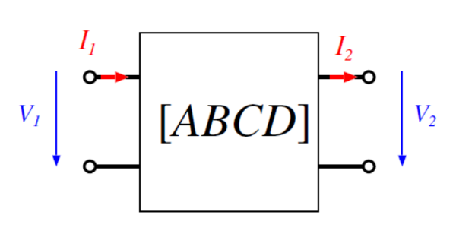

So, V1 = AV2 + BI2

I1 = CV2 + DI2

### Transfer function analysis

Transfer function is the easiest way to summarize the behavior of the filter. It determines how an output signal is related with the input signal at a specific frequency. A low pass EMI filter allows low frequency AC signals to pass a current through the filter circuit. The output coming from the filter will be attenuated, depending on the frequency of the input signal provided. A number of lumped components are used to construct filter circuits having various characteristics. The transfer function can easily determine from a graph of the output signal at various frequencies and can easily calculate using Kirchhoff’s laws.

$$H\left(f\right)=\frac{V_{out}\left(f\right)}{V_{in}\left(f\right)}; \left|H\left(f\right)\right|= \left|\frac{V_{out}\left(f\right)}{V_{in}\left(f\right)}\right|; θ=arg H\left(f\right)$$

When a signal passes through the filter, the filter will apply some phase shift to the output signal with respect to the input signal. That means a transfer function is a complex function of frequency, and the transfer function contains all the information to determine the magnitude of the output signal and its phase.

We can calculate transfer function using ABCD parameter more easily. Where ABCD matrix can be calculated using S parameter. So, to get the transfer function from the ABCD parameters, we can use the equation shown below where the source impedance and the load impedance both are 50 Ω.

$$H\left(f\right)=\frac{V_{out}\left(f\right)}{V_{in}\left(f\right)}=\frac{Z_{L}}{AZ_{L}+B+CZ_{S}Z_{L}+DZ_{S}}$$

As ABCD parameters are complex quantities and are frequency dependent, the transfer function will also have a complex phase and magnitude as a function of frequency. Putting the value of ZL and ZS we can find the value of ABCD parameter and then we can find transfer function as well. As S parameters are in complex so we have used MATLAB to solve these solutions using it.

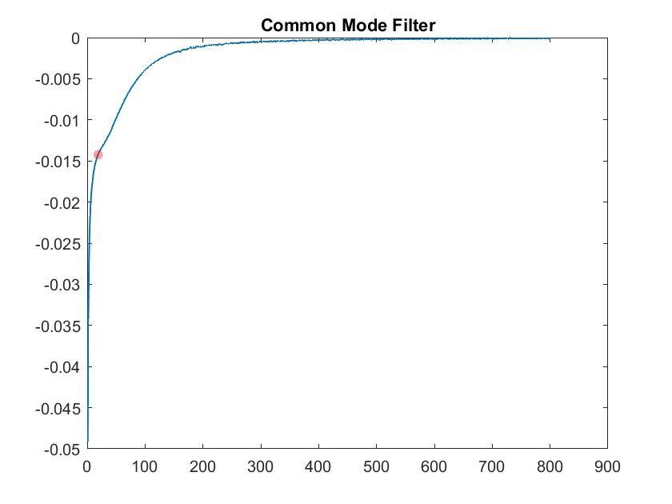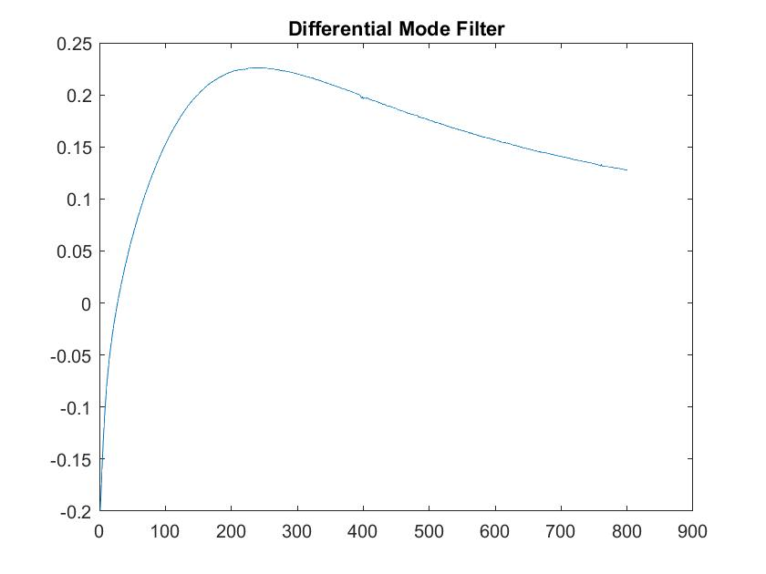

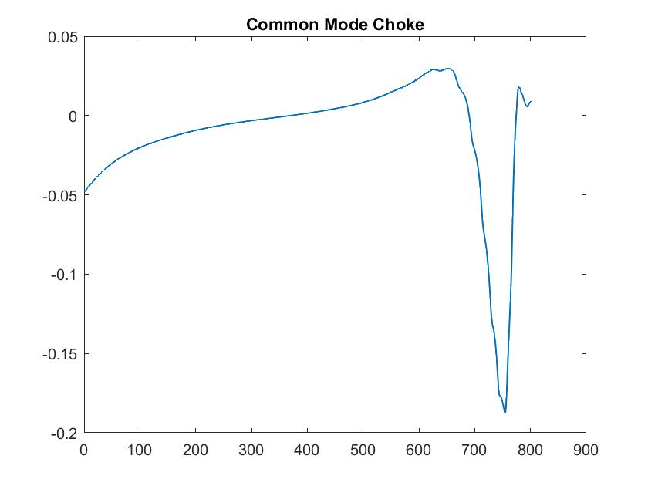

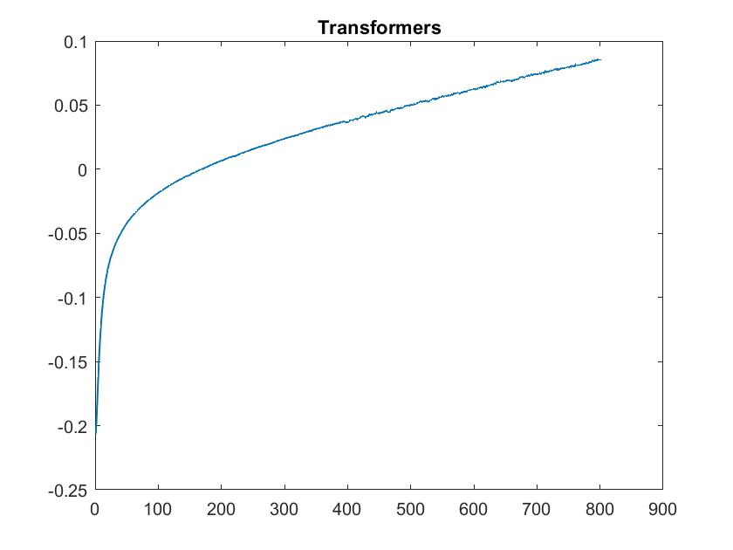

<https://resources.system-analysis.cadence.com/blog/2020-how-to-calculate-a-transfer-function-from-s-parameters>

<https://resources.pcb.cadence.com/blog/2019-low-pass-filter-transfer-functions>

#### Reflections on transmission lines

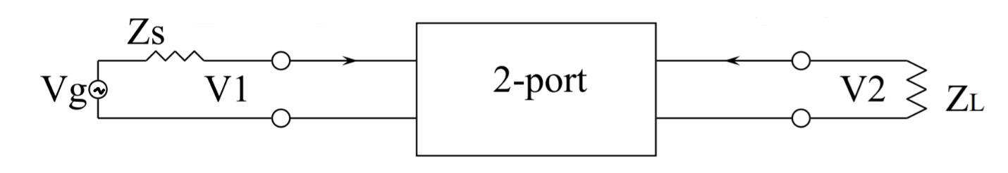

### Insertion Loss Measurement

Generally when a signal is generated and travels through a transmission line to a component or circuit then the signal losses some power due to the noise or component limitations. While transmitting the RF signal from one port to another port this total amount of loss power is called insertion loss.

Insertion loss is the ration of the output power and the input power. It is measured in decibels (dB) scale. The formula to identify the insertion loss is given bellow

Insertion Loss = 10 $\log_{10}\left[\frac{P_{out}}{P_{in}}\right] dB$

Insertion loss can be measured using the S parameter. It is denoted by S21. So the above equation can also be written in terms of S parameter as:

Insertion Loss = 10 $\log_{10}\left[S_{21}\right] dB$

The DM and CM without EMI filter are measured; the required insertion losses (ILDM and ILCM) can be determined by subtracting the emission limit from the measured DM and CM noise levels without filter.



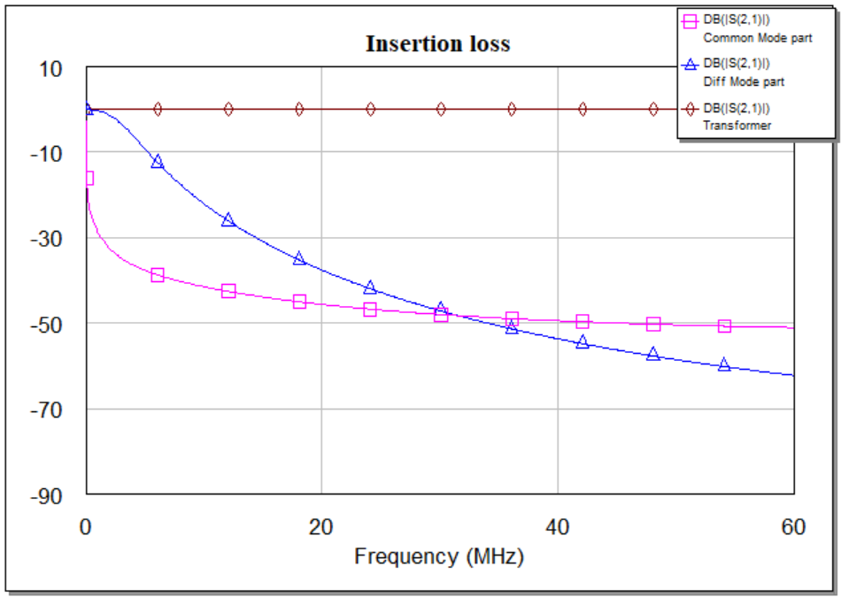

<https://medium.com/@emianalyst/emi-filter-insertion-loss-f4837d3ea051>

<https://www.schaffner.com/fileadmin/media/downloads/application_note/Schaffner_AN_RB_common_chockes.pdf>

#### Common Mode Insertion Loss

Common mode insertion loss is the attenuation of a signal applied between the ground and the shorted input terminals. This attenuated signal induces in between the shorted output terminals and the ground.



#### Differential Mode Insertion Loss

DM insertion loss is also the attenuation of the signal provided to the filter input terminals. The attenuated signal appears across the output terminals.



## Nonlinear Simulation

A nonlinear simulation is a process which only can be operated in the time domain. Circuit simulators analyze the nonlinear components in the time domain and the harmonic balance technique is used to predict nonlinear circuit behavior. Nonlinear devices have multiple mathematical solutions for the input parameters but this simulation provides a stable solution and it cannot withdraw the noise fluctuation affecting the system. It does not need to relate to the input signal and only can converge to mathematical solutions. The process of developing a compact model is costly, time consuming. The cost of model development is significant, and the quality and availability vary among integrated device manufacturers.

As, harmonic balance (HB) is a frequency-domain technique as well as a time domain integration for the prediction of nonlinear-circuit behavior. Time-domain approach is not practical always for a nonlinear circuits. It may require long simulation times before reaching the stationary state.

### CHARACTERIZING NONLINEARITY

Nonlinear devices perform critical functions from frequency to signal amplification conversion. Under large-signal handling conditions, they distort waveforms in time domain or in short, generate harmonics, inter-modulation and spectral re-growth (frequency domain). Sometimes the behavior is used, as in the case of a mixer or frequency doubler, sometimes it must be managed, as in the case of a linear amplifier.

Nonlinear measurements does not scale with the stimulus. A microwave network analyzer measures the ratio between the stimulus and the response in order to characterize the linear EUT. A large-signal VNA must measure absolute values in order to represent nonlinear EUT behavior.

A series of equations in time or frequency domain using voltages or currents can be used to measure nonlinear behavior. At all ports the voltage-current combination represents the state of the device in a unique way.

### NONLINEAR BEHAVIOR

A periodic signal can be represented both in the time or frequency domain. When such a signal drives a device into its nonlinear region, the shape of the waveform is distorted in such a way that it cannot be described simply by applying a scaling factor to the input signal. In the frequency domain, this behavior can be represented by changes to the harmonic and inter-modulation spectral components as functions of the changing boosts and terminal impedances. The harmonic distortion model is fundamentally dependent on frequency-domain measurements. It is identified from the responses of Equipment under test (EUT). This EUT is inspired by a set of discrete tones, where these tones are relatively small. For this reason the principle of harmonic superposition may be applied correctly.

### HARMONIC BALANCE TECHNIQUES

Now a day’s harmonic balance (HB) algorithm is very common to solve nonlinear networks. The HB algorithm splits the main circuit into two sub-circuits, a linear sub-circuit and a nonlinear sub-circuit. It is also called frequency domain method for identifying the steady state. A sinusoidal signal is applied to a nonlinear component in the system. That signal will generate harmonics of the fundamental frequency in a certain range. With the fundamental simulation frequency (known as input tone), number of harmonic tones required for accurate representation of the nonlinear distortion. For a single tone HB solver only single frequency analyses such as Vin/Vout, Pin/Pout, are performed. With multi tone, the analyses can include the inter-modulation distortion. With the number of tones defined the HB solver splits the circuit into two sub-groups, linear and nonlinear, and proposes a set of voltages at the interface of these subgroups. These set of voltages are defined in the frequency domain. The voltages are firstly transmitted to the time domain and applied across the nonlinear models and then converted to the frequency domain again. If the simulation is to be conducted over a frequency range, then the sources should be appropriately updated and the algorithm should be repeated until the frequency set is covered.

### TIME-DOMAIN ANALYSIS

The best way to find out how a filter will perform is through simulation is time domain simulation. It is a recently proposed technique that represents the response and simulate in time-domain waveforms. This technique is essential for finding signal distortion due to device nonlinearity. The time-domain solution is converted into the frequency-domain via fast Fourier transform (FFT).

<https://www.evaluationengineering.com/home/article/13000347/simulating-emi-filters-with-timedomain-waveforms>

According to the continuity equation the nonlinear currents is equal to the linear currents. The repeatedly done process of misbalancing the currents between the linear and nonlinear network nodes can make the simulation time lengthy and sometime it may fail to converge.

#### Voltage analysis

For analyzing the voltage, time domain analysis is a very common and easy technique to identify the input voltage as well as the output voltage at the load. This voltage either can be in time domain or in frequency domain. We have measured voltage for a specific period. Which is denoted by Vfft. It is the spectrum calculation process of the specified periodic voltage waveform using FFT. That measurement is used with APLAC HB simulator. For making the simulation more emphasize one more technique was applied which is harmonics voltage analysis. It was used to measure the voltage spectrum at a specific point which is specified by the probe at referenced to ground. For the above measurements a common term the number harmonics specified the highest frequency used in the spectrum.

As the entire filter is divided into two part according to the level of noise induced so every measurement divided systematically.

##### Common Mode measurement

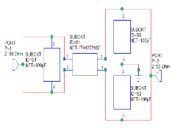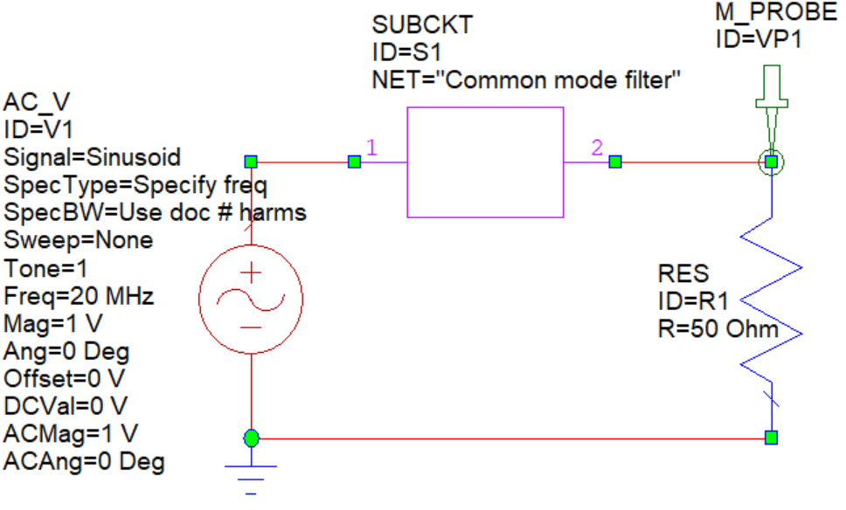

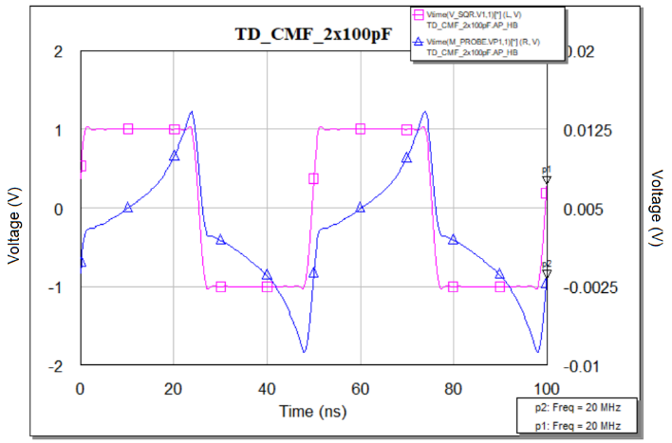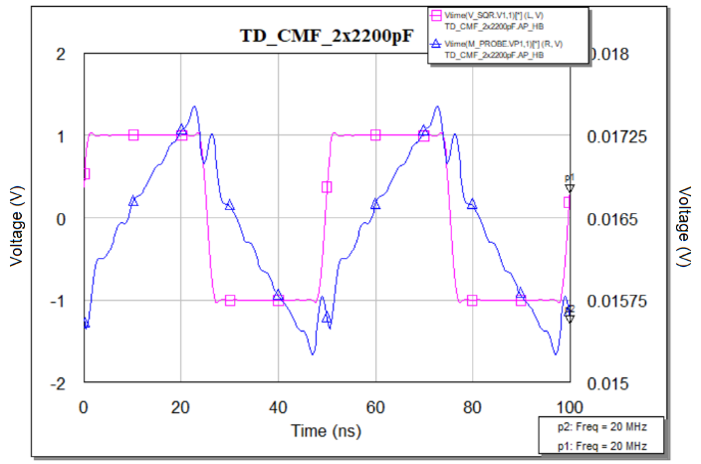

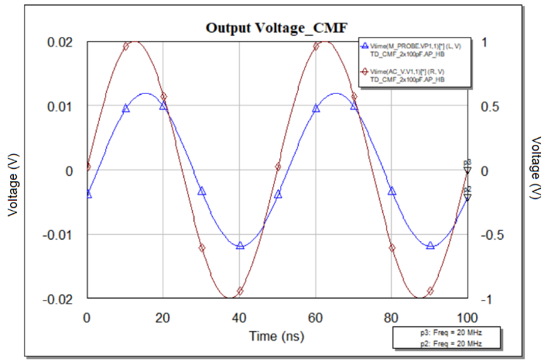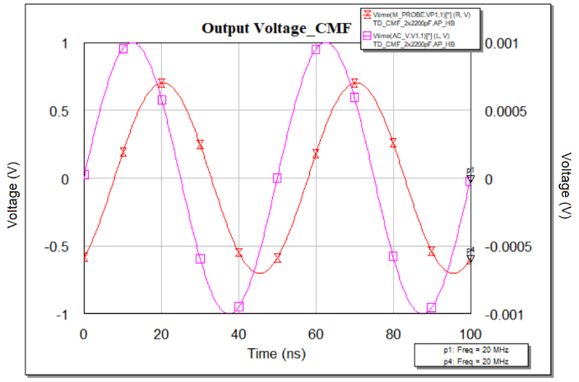

Figure: Common mode voltage measurement in time domain using different capacitor

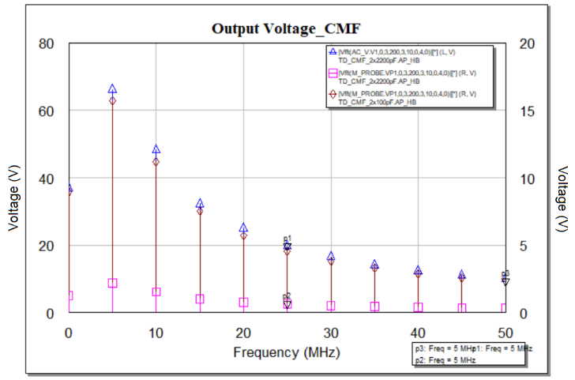 

Figure: Common mode voltage measurement in Frequency domain using different capacitor

#### Observation

Looking deeper into this circuit, however, it has single sinusoidal source. According to the basic structure of a common mode, signal is passing through both line and neutral. Due to the common mode choke the voltage is decreasing and at the output we are getting low voltage. In the above Figure two set of capacitor were being used as the Y cap. Where for the set of 100pF cap the voltage drop across the load is lower than the set of 2200pF. We can easily observe the result in FFT domain simulation.

##### Differential mode measurement

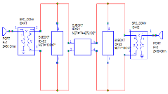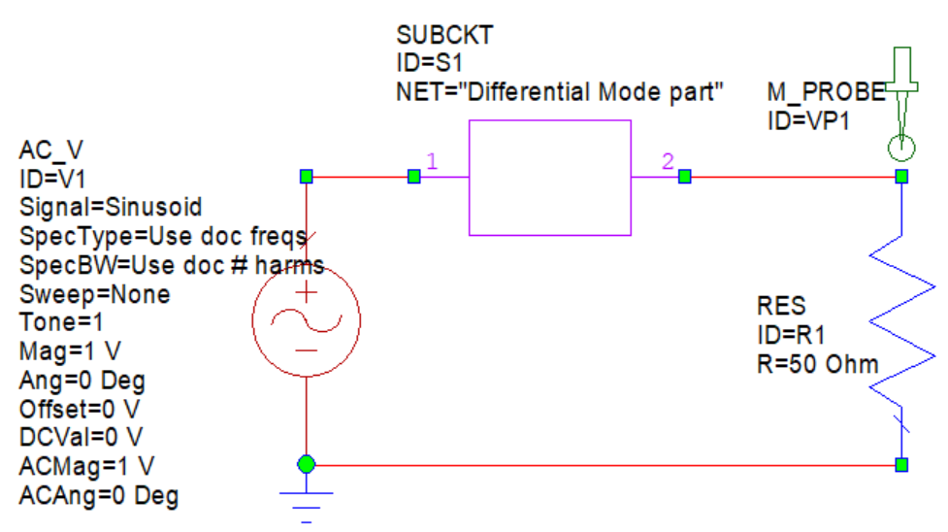

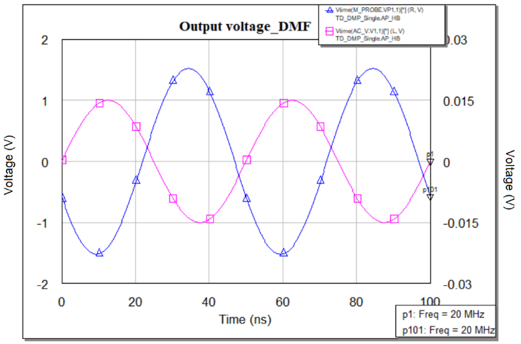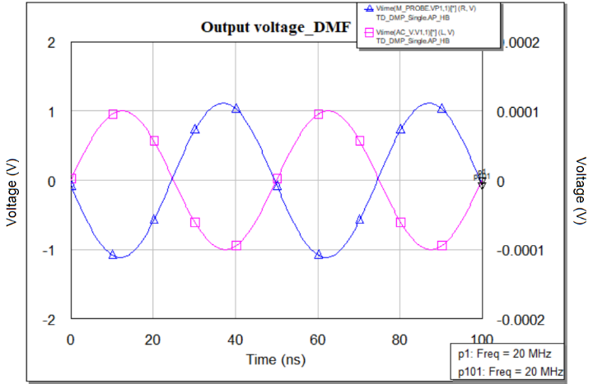

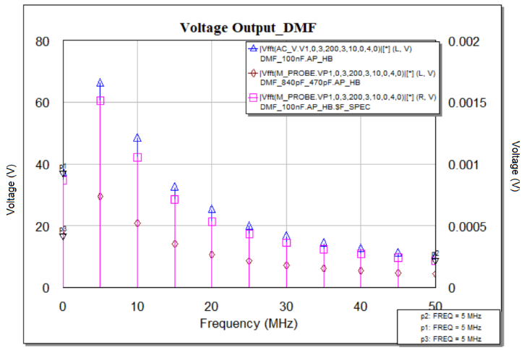

Figure: Differential mode voltage measurement in Frequency domain using different capacitor

#### Observation

Differential mode noise is generated due to the source and common mode leakage inductance. We have use two set of capacitor where the maximum voltage drop can easily observe for set of 0.1uF in the load.

#### Multi-tone Analysis

Now as an advanced technique multi-tone analysis is commonly used for testing electronic devices whether it can be passive devices like filters or active device like amplifiers. This test is done for nonlinear behavior devices, in this report we have applied this test to linear device like Electromagnetic interference filter (EMI). Multi-tone testing uses a number of tones to test equipment under test (EUT) and this technique is more efficient compared to single tone and two tone testing. This test stand for an operation of generating multi-tone signals consisting of a summation of sine waves connected to the EUT which are connected to spectrum analyzer to obtain the frequency response and analyze it for the tested device, if it satisfied the determined specification needed, then we decide to accept this device or neglect it by calculating a crest factor (CF) which is the ratio of peak amplitude of the waveform and the rms value.

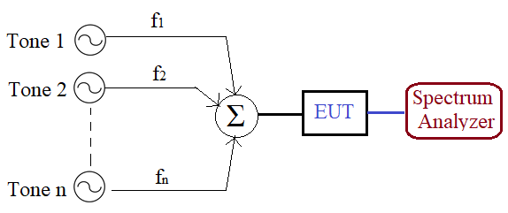

Figure: Multi tone measurement process

When a sinusoid single is passed through a linear network, the amplitude and phase changes are not considered as distortion. However, when a complex, time-varying signal is passed through a linear network, the amplitude and phase shifts can dramatically distort the time domain waveform. In a nonlinear device, input signal can be shifted in frequency and create new output signal in the form of harmonics. For doing the test we have used three sinusoidal signals in the input and easily it can be seen that the output signal is generated in the form of harmonics with different order.

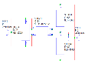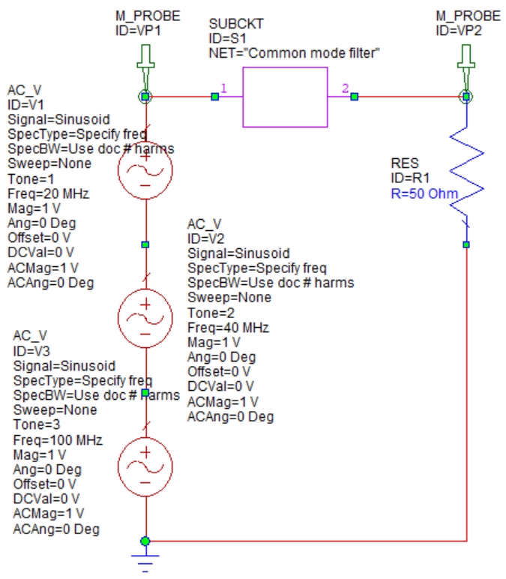 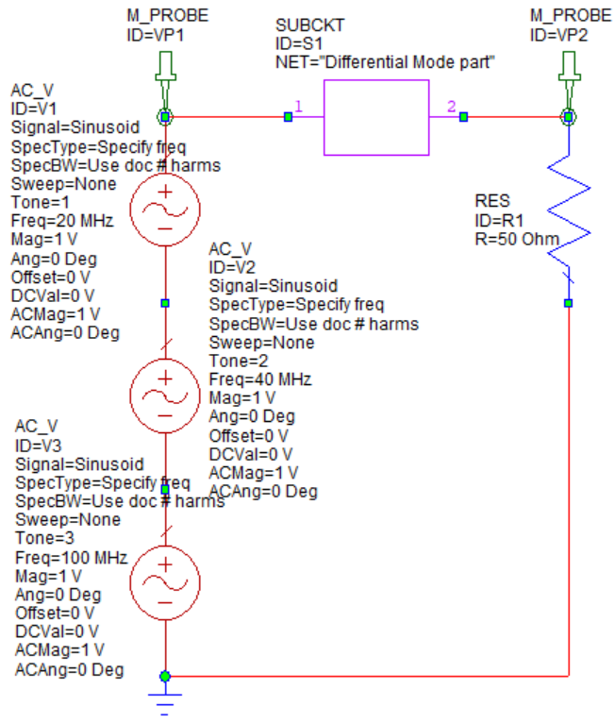

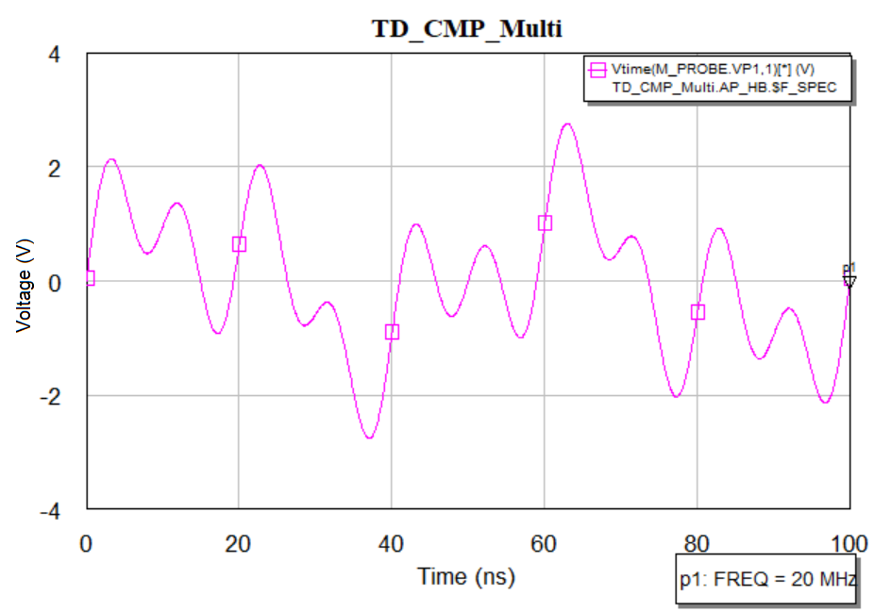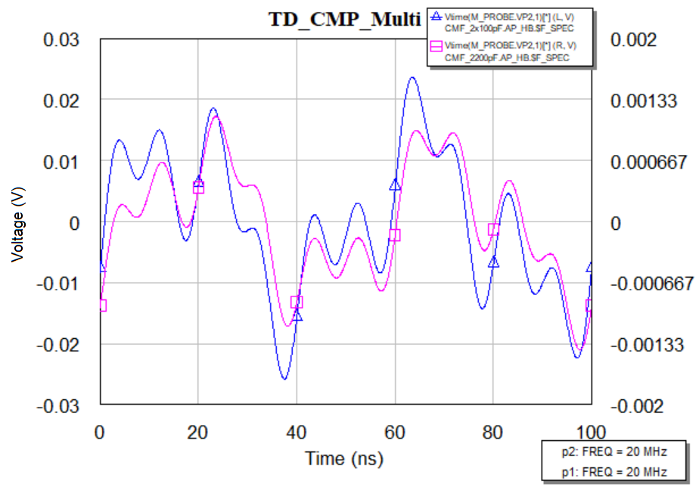

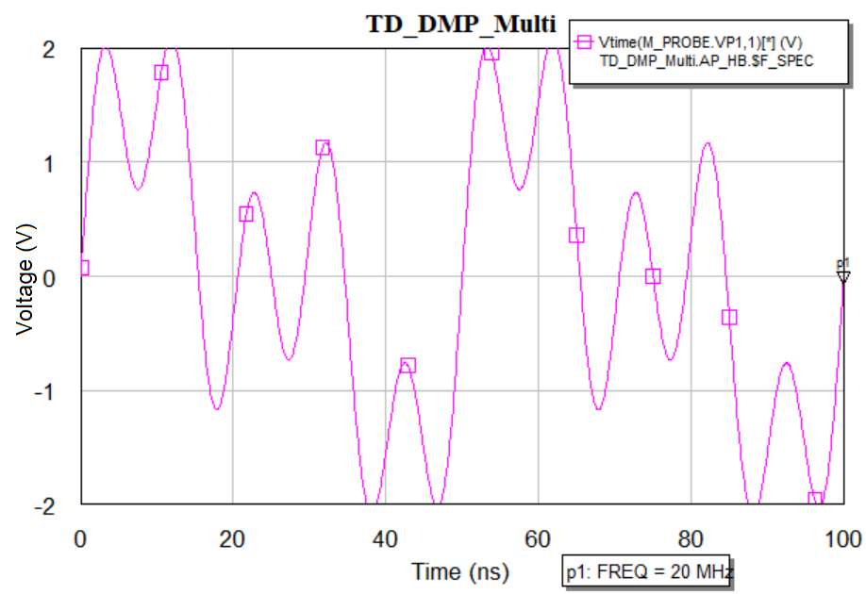 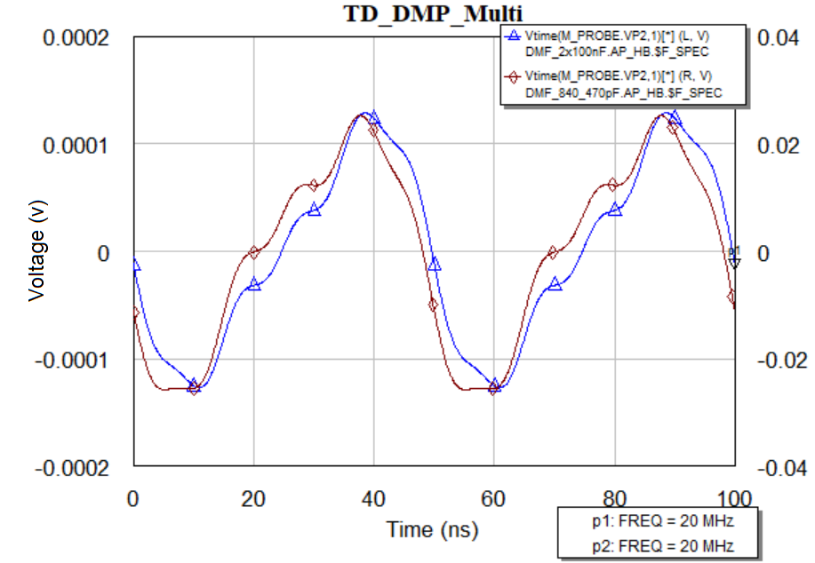

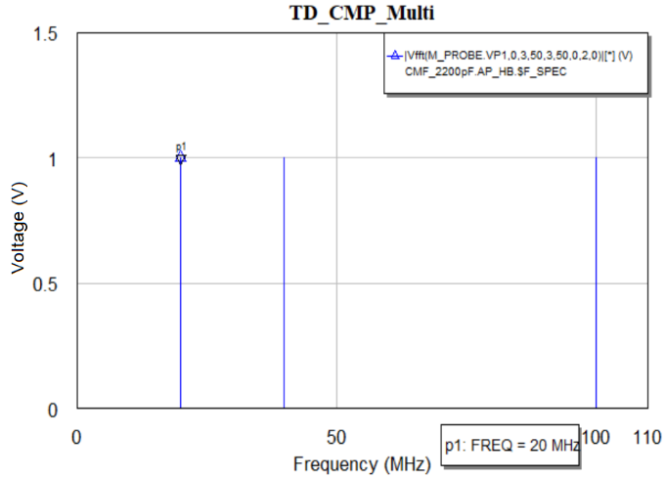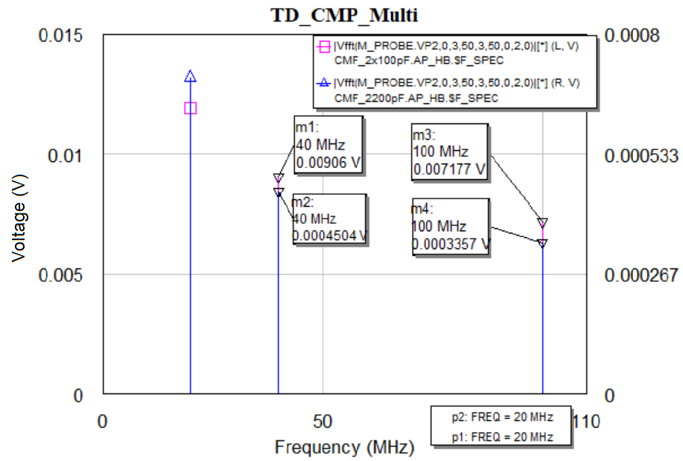

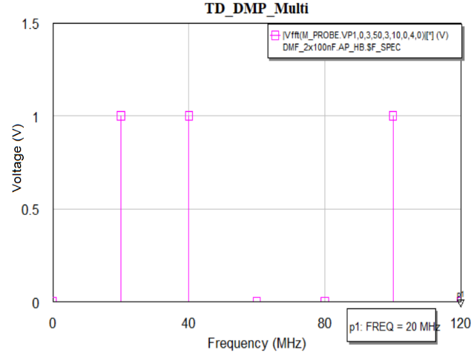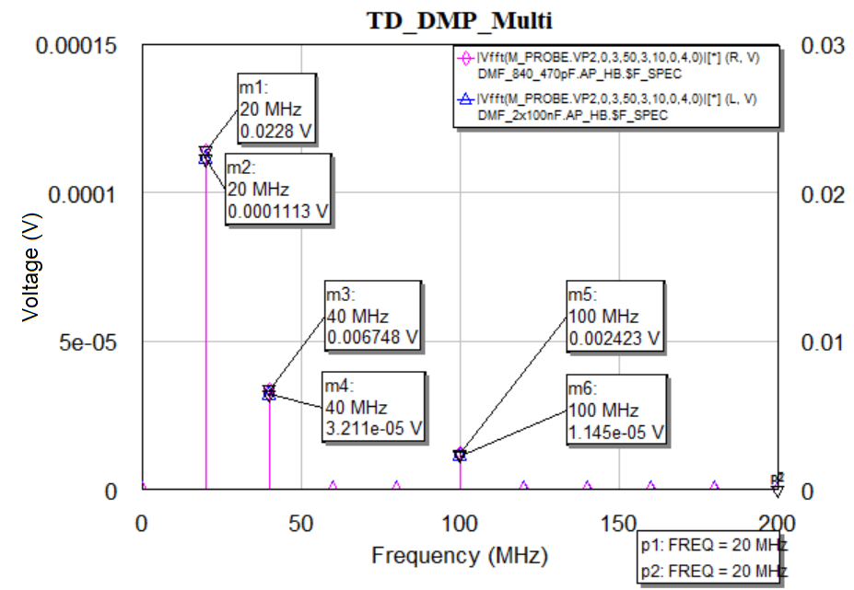

Figure: Multi tone analysis a) CM filter schematic, b) DM filter schematic,

1. CM input signal TD response, d) CM output signal TD response using 2x100 and 2x200pf cap
2. DM input signal TD response, f) DM output signal TD response of 100nF and 840,470pf cap, g) CM input signal FD response h) CM output signal FD response using 2x100 and 2x200pf cap,
3. DM input signal FD response, j) DM output signal FD response of 100nF and 840,470pf cap

#### Power analysis

|  |  |  |  |  |
| --- | --- | --- | --- | --- |
| Frequency  (MHz) | Noise power (dBm) | Output power  (no cap) dBm | Output power  (2X100pF) dBm | Output power  (2X2200pF) dBm |
| 12 | -18.50 | -48.6 | -52.7 | -75.2 |
| 36 | -18.50 | -50.3 | -52.1 | -78.1 |
| 60 | -19.5 | -42.8 | -60.6 | -86.4 |
| 84 | -20.3 | -48.3 | -58.1 | -85.2 |
| 108 | -22.6 | -44 | -65.3 | -90.5 |
| 132 | -22.9 | -53.7 | -70.8 | -92.8 |
| 156 | -23.5 | -51.1 | -67.5 | -84.3 |
| 180 | -26.1 | -46.3 | -69.6 | -83.0 |
| 204 | -27.8 | -47.3 | -67.7 | -78.1 |
| 228 | -29.6 |  | -74.0 | -81.2 |

|  |  |  |  |  |
| --- | --- | --- | --- | --- |
| Frequency  (MHz) | Noise power (dBm) | Output power  (no cap) dBm | Output power  (1X100nF) dBm | Output power  (820pF &470pF) dBm |
| 12 | -18.50 | -24.6 | -49.1 | -29.5 |
| 36 | -18.50 | -35.6 | -51 | -47.6 |
| 60 | -19.5 | -33.8 | -44.9 | -59.6 |
| 84 | -20.3 | -38.6 | -47.3 | -48.1 |
| 108 | -22.6 | -33.7 | -41.3 | -48.2 |
| 132 | -22.9 | -41.1 | -47.9 | -45.2 |
| 156 | -23.5 | -31.3 | -37.3 | -37.9 |
| 180 | -26.1 | -30.4 | -34 | -31.1 |
| 204 | -27.8 | -30.8 | -34.4 | -33.9 |
| 228 | -29.6 |  |  |  |

#### 

Figure: A. Hardware simulation for CM filter; B. Hardware simulation for DM filter

|  |  |  |  |  |  |  |
| --- | --- | --- | --- | --- | --- | --- |
| Frequency  (MHz) | Noise power (dBm) | Output power  (no cap) dBm | Output power  (2X100pF) dBm | | Output power  (2X2200pF) dBm | |
| Sym com | real com | Sym com | real com |
| 12 | -18.46 | -54.03 | -56.02 | -65.36 | -78.37 | -78.32 |
| 36 | -18.46 | -51.08 | -59.02 | -63.58 | -85.31 | -85.79 |
| 60 | -19.46 | -49.77 | -61.67 | -63.56 | -88.58 | -93.14 |
| 84 | -20.24 | -48.44 | -63.13 | -63.7 | -92.7 | -97.99 |
| 108 | -21.1 | -47.32 | -64.12 | -64.31 | -96.25 | -112.1 |
| 132 | -22.85 | -47.52 | -66.05 | -66.38 | -103.1 | -97.47 |
| 156 | -23.47 | -46.74 | -66.74 | -67.25 | -113.7 | -91.5 |
| 180 | -26.08 | -48.14 | -69.57 | -70.34 | -105.8 | -89.75 |

|  |  |  |  |  |  |  |
| --- | --- | --- | --- | --- | --- | --- |
| Frequency  (MHz) | Noise power (dBm) | Output power  (no cap) dBm | Output power  (1X100nF) dBm | | Output power  (820pF &470pF) dBm | |
| sym com | real com | sym com | real com |
| 12 | -18.46 | -37.53 | -33.59 | -39.71 | -43.07 | -42.61 |
| 36 | -18.46 | -45.77 | -62.45 | -65.51 | -59.07 | -57.65 |
| 60 | -19.46 | -49.01 | -69.25 | -70.41 | -63.94 | -61-94 |
| 84 | -20.24 | -49.82 | -71.29 | -73.2 | -61.14 | -57.63 |
| 108 | -21.1 | -49.33 | -71.37 | -74.71 | -54.47 | -61.0 |
| 132 | -22.85 | -49.01 | -71.36 | -73.88 | -70 | -73.52 |
| 156 | -23.47 | -46.61 | -69.17 | -71.25 | -74.39 | -78.23 |
| 180 | -26.08 | -45.16 | -67.87 | -69.77 | -77.35 | -81.99 |



Figure: A. Software simulation for CM filter; B. Software simulation for DM filter



Figure: Noise power for both filter both in Software and Hardware platform

### Measurement Comparison

#### Common Mode Filter







Figure: Comparison between Hardware and Software simulation with different components.

#### Differential Mode Filter







Figure: Comparison between Hardware and Software simulation with different components.

##### Discussion

An Electromagnetic Interference (EMI) filter is consist of two basic part which are Common mode part and Differential Mode part. These two part can be implemented individually considering all the parameters and simulation process in equal manner. In this thesis work we have implemented these two basic part of an EMI filter and tested the variation in frequency domain replacing the parasitic components (capacitors).

For a common mode part the hardware and software testing have been considered following three criteria.

1. Considering the common mode choke as a common mode filter
2. Considering the parasitic components value as they are being used in market
3. Considering the parasitic components value focusing only on trigger point.

LISN

1. <https://electronics.stackexchange.com/questions/413317/how-to-simulate-the-impedance-for-this-lisn-circuit-in-ltspice>
2. <https://incompliancemag.com/article/topology-and-characterization-of-a-dc-line-impedance-stabilization-network/>

# Chapter 5. Result Estimation and Discussion